Install the **experimental version** of the Gateway API CRDs:

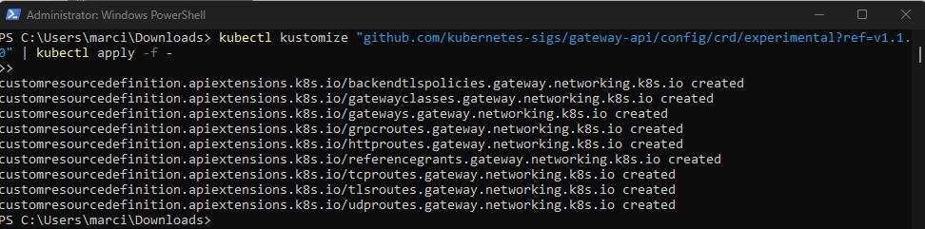Configure Istio to read the alpha Gateway API resources by setting the PILOT_ENABLE_ALPHA_GATEWAY_API environment variable to true when installing Istio:

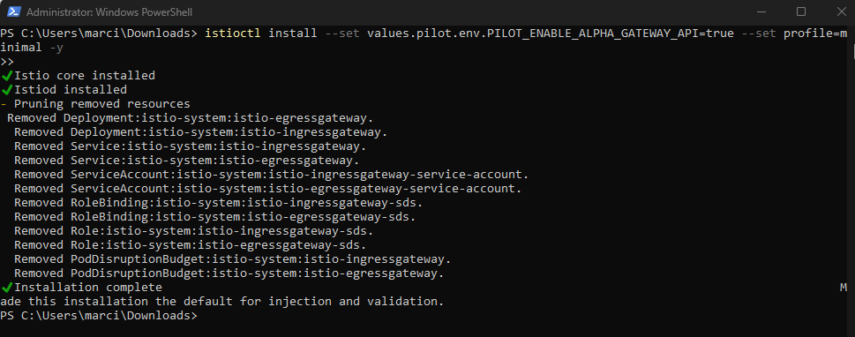

Define Service versions:

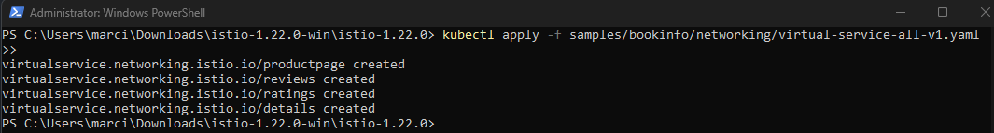

Route all traffic to v1:

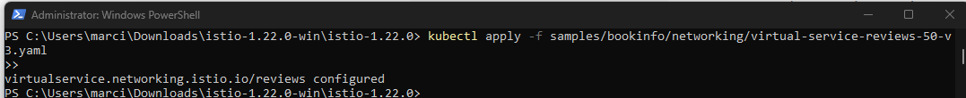

Route 50% of the traffic from v1 to v3:



Confirm rules changed:

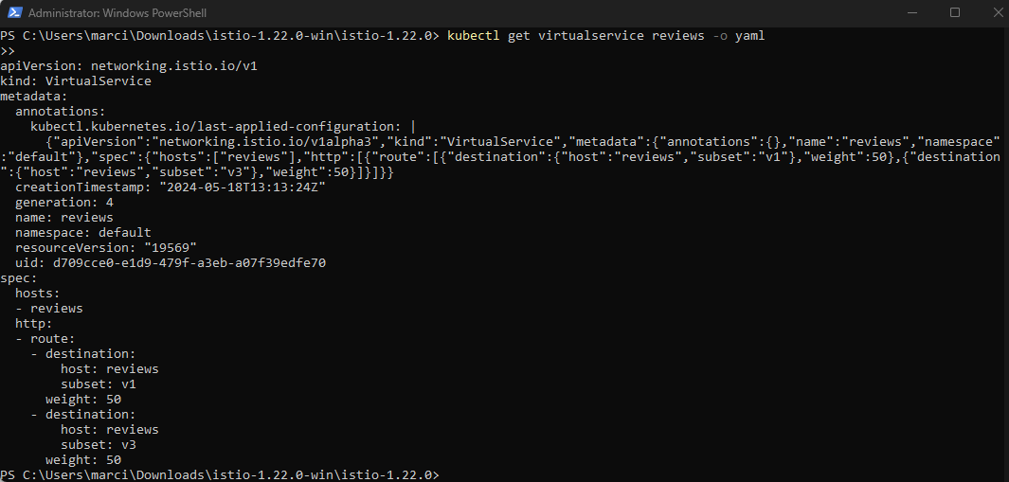

Moving all the traffic to v3:



Remove all routing rules:

